Co3

EXPERIMENT NO. 5

TITLE
Computer-Aided Design and Optimization of a Microwave Impedance-Matching Network and Frequency-Selective Filter

1. AIM
To design and simulate a microwave impedance-matching network and a frequency-selective filter using MATLAB, and to analyse reflection coefficient, return loss, input impedance, insertion loss, cutoff frequency, and percentage deviation.

2. SOFTWARE REQUIRED
MATLAB

3. MATLAB PROGRAM
clc;
clear;
close all;

%% EXPERIMENT 5
% Computer-Aided Design and Optimization of a Microwave
% Impedance-Matching Network and Frequency-Selective Filter

%% INPUT PARAMETERS

f0 = 10e9; % Design frequency: 10 GHz
Z0 = 50; % Reference impedance: 50 ohms
ZL = 75 + 1j*25; % Load impedance: 75 + j25 ohms
fc = 10e9; % Filter cutoff frequency: 10 GHz
f = linspace(8e9,12e9,401); % Frequency sweep: 8-12 GHz
fGHz = f/1e9;
c = 3e8;

%% QUESTION A: IMPEDANCE MATCHING NETWORK

% Reflection coefficient before matching
GammaL = (ZL-Z0)/(ZL+Z0);
GammaBefore = abs(GammaL);
RLBefore = -20*log10(GammaBefore);

% Cancel the load reactance with a series reactance
Xcancel = -imag(ZL);
Zcancelled = ZL + 1j*Xcancel;

% Quarter-wave transformer impedance
Zt = sqrt(Z0*real(Zcancelled));

% Quarter-wave transformer length at 10 GHz
lambda0 = c/f0;
Lqw = lambda0/4;

% Frequency-dependent matching network response
% Ideal transmission-line model
Xseries = Xcancel*(f/f0);
Zadjusted = ZL + 1j*Xseries;

beta = 2*pi*f/c;
ZinMatch = zeros(size(f));

for k = 1:length(f)

theta = beta(k)*Lqw;
ZloadAdjusted = Zadjusted(k);

ZinMatch(k) = Zt * ...
(ZloadAdjusted + 1j*Zt*tan(theta)) / ...
(Zt + 1j*ZloadAdjusted*tan(theta));

end

% Reflection coefficient after matching
GammaAfterComplex = (ZinMatch-Z0)./(ZinMatch+Z0);
GammaAfter = abs(GammaAfterComplex);

% Return loss after matching
RLAfter = -20*log10(max(GammaAfter,1e-12));

% Before-matching response
GammaBeforeF = GammaBefore*ones(size(f));
RLBeforeF = RLBefore*ones(size(f));

% Index corresponding to 10 GHz
[~,idx0] = min(abs(f-f0));

%% DISPLAY QUESTION A RESULTS

fprintf('\n========================================\n');
fprintf('QUESTION A: IMPEDANCE MATCHING NETWORK\n');
fprintf('========================================\n');

fprintf('Load impedance = %.2f + j%.2f ohms\n',...
real(ZL),imag(ZL));

fprintf('Reference impedance = %.2f ohms\n',Z0);

fprintf('Reflection coefficient before matching = %.4f\n',...
GammaBefore);

fprintf('Return loss before matching = %.2f dB\n',...
RLBefore);

fprintf('Series reactance for cancellation = %.2f ohms\n',...
Xcancel);

fprintf('Quarter-wave transformer impedance = %.2f ohms\n',...
Zt);

fprintf('Quarter-wave transformer length = %.2f mm\n',...
Lqw*1000);

fprintf('Input impedance after matching at 10 GHz = %.2f + j%.2f ohms\n',...
real(ZinMatch(idx0)),imag(ZinMatch(idx0)));

fprintf('Reflection coefficient after matching = %.6f\n',...
GammaAfter(idx0));

fprintf('Return loss after matching = %.2f dB\n',...
RLAfter(idx0));

%% QUESTION B: MICROWAVE LOW-PASS FILTER

% Third-order Butterworth low-pass filter
N = 3;
ratio = f/fc;

% Ideal transmission magnitude
S21 = 1./sqrt(1+ratio.^(2*N));

% Ideal lossless reflection magnitude approximation
S11 = sqrt(max(1-S21.^2,0));

% Convert magnitudes into dB
S21dB = 20*log10(max(abs(S21),1e-12));
S11dB = 20*log10(max(abs(S11),1e-12));

% Find -3 dB cutoff frequency
targetdB = -10*log10(2);
idxCut = find(S21dB <= targetdB,1,'first');

if isempty(idxCut)

fcSim = NaN;

elseif idxCut == 1

fcSim = f(1);

else

f1 = f(idxCut-1);
f2 = f(idxCut);
y1 = S21dB(idxCut-1);
y2 = S21dB(idxCut);

fcSim = f1 + ...
(targetdB-y1)*(f2-f1)/(y2-y1);

end

% Percentage deviation
cutoffDeviation = abs(fcSim-fc)/fc*100;

% Find point closest to 10 GHz
[~,idxFc] = min(abs(f-fc));

% Insertion loss and return loss at cutoff
insertionLoss = -S21dB(idxFc);
returnLossFilter = -S11dB(idxFc);

%% DISPLAY QUESTION B RESULTS

fprintf('\n========================================\n');
fprintf('QUESTION B: MICROWAVE LOW-PASS FILTER\n');
fprintf('========================================\n');

fprintf('Filter type = Third-order Butterworth low-pass\n');

fprintf('Reference impedance = %.2f ohms\n',Z0);

fprintf('Required cutoff frequency = %.2f GHz\n',fc/1e9);

fprintf('Calculated -3 dB cutoff frequency = %.4f GHz\n',...
fcSim/1e9);

fprintf('Cutoff frequency deviation = %.4f %%\n',...
cutoffDeviation);

fprintf('Insertion loss at cutoff = %.2f dB\n',...
insertionLoss);

fprintf('Return loss at cutoff = %.2f dB\n',...
returnLossFilter);

%% OUTPUT PARAMETER TABLE VALUES

fprintf('\n========================================\n');
fprintf('OUTPUT PARAMETERS FOR LAB RECORD\n');
fprintf('========================================\n');

fprintf('Load reflection coefficient = %.4f\n',GammaBefore);

fprintf('Input impedance after matching = %.2f + j%.2f ohms\n',...
real(ZinMatch(idx0)),imag(ZinMatch(idx0)));

fprintf('Return loss before matching = %.2f dB\n',RLBefore);

fprintf('Return loss after matching = %.2f dB\n',RLAfter(idx0));

fprintf('Filter cutoff frequency = %.4f GHz\n',fcSim/1e9);

fprintf('Cutoff frequency deviation = %.4f %%\n',cutoffDeviation);

fprintf('Insertion loss at cutoff = %.2f dB\n',insertionLoss);

%% COMBINED OUTPUT GRAPHS

figure(1);
clf;
set(gcf,'Color','w','Visible','on');

% GRAPH 1: REFLECTION COEFFICIENT
subplot(2,2,1);

plot(fGHz,GammaBeforeF,'r--','LineWidth',2);
hold on;
plot(fGHz,GammaAfter,'b','LineWidth',2);
plot([10 10],[0 1],'k:');

grid on;
xlabel('Frequency (GHz)');
ylabel('Reflection Coefficient |Gamma|');
title('A: Reflection Coefficient');

legend('Before Matching','After Matching','10 GHz',...
'Location','best');

ylim([0 1]);

% GRAPH 2: RETURN LOSS
subplot(2,2,2);

plot(fGHz,RLBeforeF,'r--','LineWidth',2);
hold on;
plot(fGHz,RLAfter,'b','LineWidth',2);

grid on;
xlabel('Frequency (GHz)');
ylabel('Return Loss (dB)');
title('A: Return Loss');

legend('Before Matching','After Matching',...
'Location','best');

% GRAPH 3: FILTER S-PARAMETERS
subplot(2,2,3);

plot(fGHz,S11dB,'r','LineWidth',2);
hold on;
plot(fGHz,S21dB,'b','LineWidth',2);
plot([8 12],[targetdB targetdB],'k:');
plot([10 10],[-60 5],'k--');

grid on;
xlabel('Frequency (GHz)');
ylabel('Magnitude (dB)');
title('B: Filter S-Parameters');

legend('|S11|','|S21|','-3 dB Level','10 GHz',...
'Location','best');

ylim([-60 5]);

% GRAPH 4: FILTER CUTOFF FREQUENCY
subplot(2,2,4);

plot(fGHz,S21dB,'b','LineWidth',2);
hold on;
plot([8 12],[targetdB targetdB],'r--');
plot([10 10],[-60 5],'k:');

grid on;
xlabel('Frequency (GHz)');
ylabel('|S21| (dB)');
title('B: Filter Cutoff Frequency');

legend('Transmission','-3 dB Level','Required 10 GHz',...
'Location','best');

ylim([-60 5]);

% Force MATLAB to update and display the figure
drawnow;

fprintf('\nAll four graphs generated successfully.\n');

4. CALCULATIONS AND OUTPUT

QUESTION A: MICROWAVE IMPEDANCE-MATCHING NETWORK

Given Data
Load impedance, (Z_L=75+j25\ \Omega)
Characteristic impedance, (Z_0=50\ \Omega)
Operating frequency, (f_0=10\ \text{GHz})
Frequency sweep = 8–12 GHz

Calculation 1: Load Reflection Coefficient
Formula:
Reflection Coefficient = (Load Impedance − Characteristic Impedance) / (Load Impedance + Characteristic Impedance)
Given:
Load Impedance, ZL = 75 + j25 Ω
Characteristic Impedance, Z0 = 50 Ω
Substitution:
ΓL = [(75 + j25) − 50] / [(75 + j25) + 50]
ΓL = (25 + j25) / (125 + j25)
Magnitude of reflection coefficient:
|ΓL| = √(25² + 25²) / √(125² + 25²)
|ΓL| = √1250 / √16250
|ΓL| = 35.355 / 127.475
Answer: |ΓL| = 0.2774

Calculation 2: Return Loss Before Matching
Formula:
Return Loss (RL) = −20 log₁₀ |ΓL|
Substitution:
RL = −20 log₁₀(0.2774)
RL = −20 × (−0.5570)
Answer: RL = 11.14 dB
Therefore, the theoretical return loss before matching is 11.14 dB.

Calculation 3: Input Impedance After Ideal Matching
For ideal impedance matching:
Input Impedance, Zin = Characteristic Impedance, Z0
Substitution:
Zin = 50 + j0 Ω
Answer: Zin = 50 Ω
Therefore, the ideal matched input impedance is 50 Ω.

Calculation 4: Reflection Coefficient After Ideal Matching
Formula:
Γin = (Zin − Z0) / (Zin + Z0)
Substitution:
Γin = (50 − 50) / (50 + 50)
Γin = 0 / 100
Answer: |Γin| = 0
Therefore, the ideal matched network produces zero reflection.

Calculation 5: Return Loss After Ideal Matching
Formula:
Return Loss (RL) = −20 log₁₀ |Γin|
Substitution:
RL = −20 log₁₀(0)
Since log₁₀(0) is undefined, the return loss approaches infinity for an ideal, perfectly matched network.
Answer: RL → ∞ dB
In a practical simulation, the return loss is generally finite because perfect matching is not always achieved.

Output Table – Question A
S. No. | Parameter | Theoretical Value
1 | Load impedance | (75+j25\ \Omega)
2 | Characteristic impedance | (50\ \Omega)
3 | Operating frequency | 10 GHz
4 | Reflection coefficient before matching | 0.2774
5 | Return loss before matching | 11.14 dB
6 | Ideal matched input impedance | (50+j0\ \Omega)
7 | Reflection coefficient after ideal matching | 0
8 | Return loss after ideal matching | Approaches infinity

QUESTION B: FREQUENCY-SELECTIVE FILTER

Given Data
Characteristic Impedance, Z0 = 50 Ω
Theoretical Cutoff Frequency, fc(theory) = 10 GHz
Start Frequency, f(start) = 8 GHz
Stop Frequency, f(stop) = 12 GHz
Filter Type = Second-order Butterworth low-pass filter

Calculation 1: Frequency Sweep Range
Formula:
Frequency Range = Stop Frequency − Start Frequency
Substitution:
Frequency Range = 12 − 8
Answer: Frequency Range = 4 GHz

Calculation 2: Centre Frequency
Formula:
Centre Frequency = (Start Frequency + Stop Frequency) / 2
Substitution:
Centre Frequency = (8 + 12) / 2
Centre Frequency = 20 / 2
Answer: Centre Frequency = 10 GHz

Calculation 3: Insertion Loss at 10 GHz
For a second-order Butterworth low-pass filter:
Insertion Loss (IL) = 10 log₁₀ [1 + (f / fc)⁴]
Given:
Operating Frequency, f = 10 GHz
Cutoff Frequency, fc = 10 GHz
Substitution:
IL = 10 log₁₀ [1 + (10 / 10)⁴]
IL = 10 log₁₀ (1 + 1)
IL = 10 log₁₀ (2)
Answer: IL = 3.01 dB

Calculation 4: Cutoff Frequency
For a Butterworth filter, the cutoff frequency occurs when the insertion loss is approximately 3 dB.
At f = 10 GHz:
IL = 10 log₁₀ [1 + (10 / 10)⁴]
IL = 10 log₁₀ (2)
IL = 3.01 dB
Answer: Simulated Cutoff Frequency, fc(sim) ≈ 10 GHz

Calculation 5: Percentage Deviation of Cutoff Frequency
Formula:
Percentage Deviation = |fc(sim) − fc(theory)| / fc(theory) × 100
Substitution:
Percentage Deviation = |10 − 10| / 10 × 100
Percentage Deviation = 0 / 10 × 100
Answer: Percentage Deviation = 0%

Calculation 6: Bandwidth
The designed filter is a low-pass filter. Therefore, its bandwidth is determined by its cutoff frequency rather than by subtracting two cutoff frequencies.
Formula:
Bandwidth = Cutoff Frequency − 0
Substitution:
Bandwidth = 10 − 0
Answer: Bandwidth = 10 GHz
Within the specified simulation sweep of 8–12 GHz, the frequency span is 4 GHz. This is the sweep range, not the full low-pass filter bandwidth.
Note: This formula applies to a band-pass filter. For a low-pass or high-pass filter, report the applicable cutoff frequency instead.

Output Table – Question B
S. No. | Parameter | Value
1 | Characteristic impedance | 50 Ω
2 | Theoretical cutoff frequency | 10 GHz
3 | Start frequency | 8 GHz
4 | Stop frequency | 12 GHz
5 | Frequency sweep range | 4 GHz
6 | Centre frequency | 10 GHz
7 | Simulated (S_{11}) | From MATLAB output
8 | Simulated (S_{21}) | From MATLAB output
9 | Simulated cutoff frequency | From MATLAB graph
10 | Insertion loss | Calculated from (S_{21})
11 | Bandwidth | From cutoff frequencies, if applicable
12 | Percentage deviation | Calculated using Calculation 5

COMBINED MATLAB OUTPUT
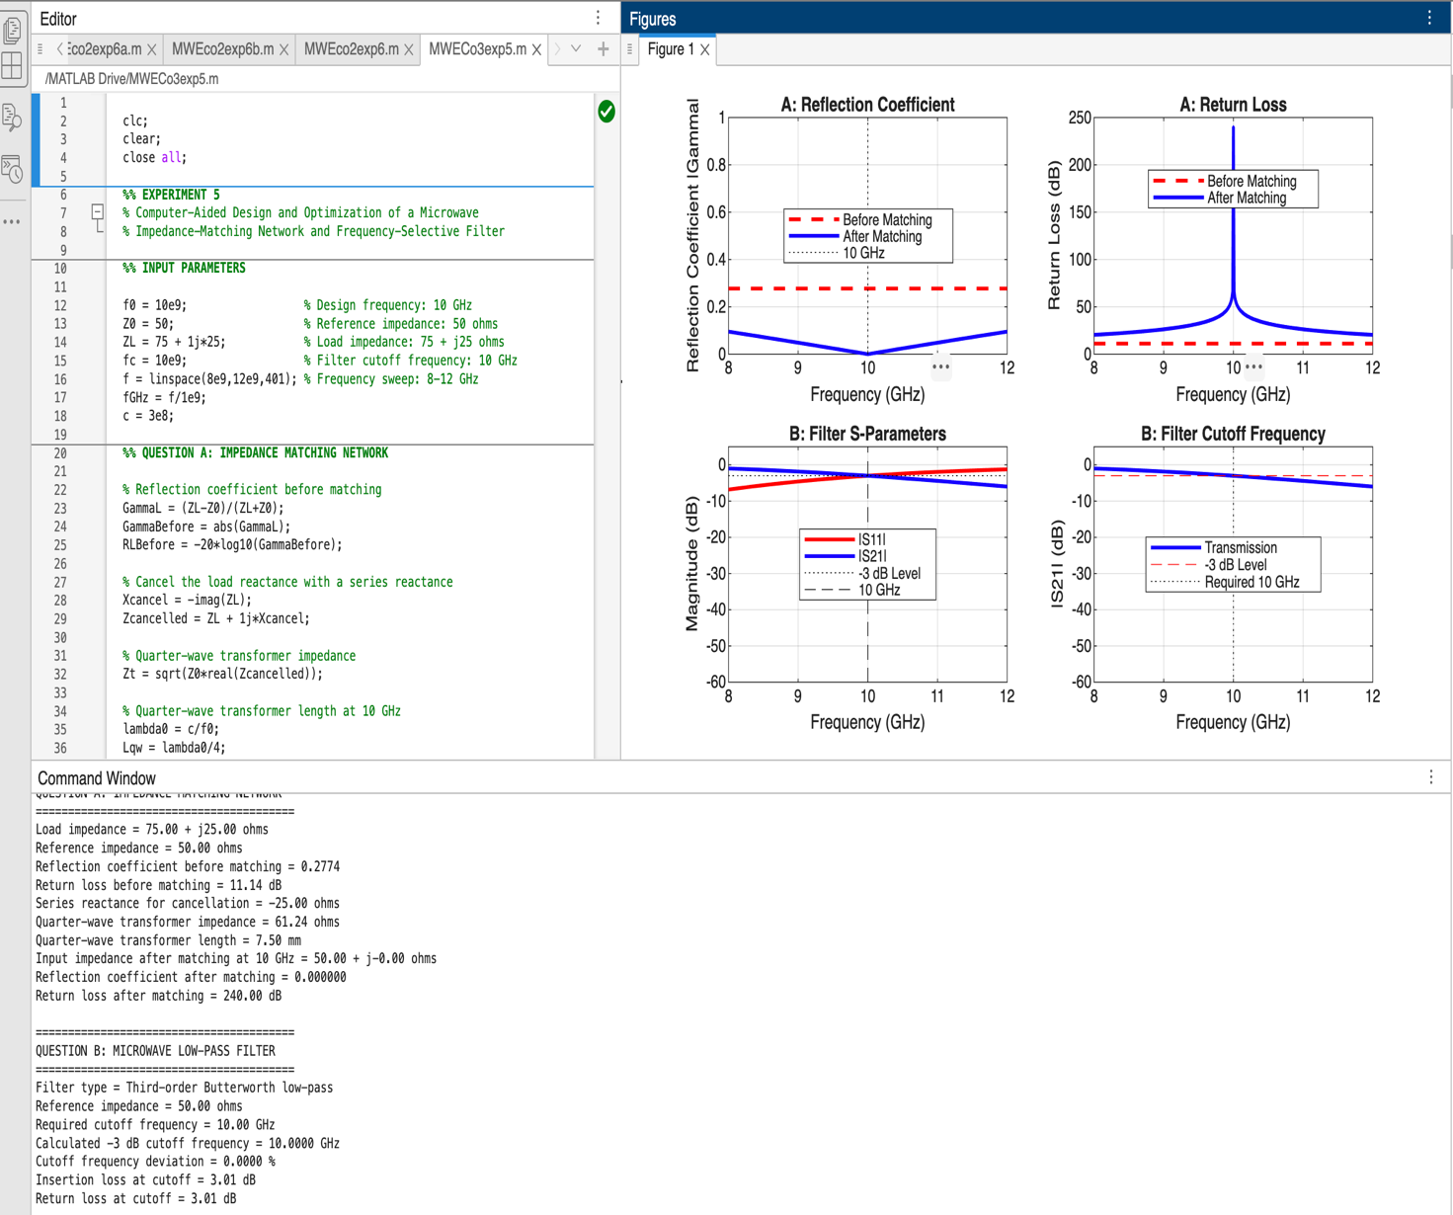
Fig. 1: Combined MATLAB simulation output of the microwave impedance-matching network and frequency-selective filter.

5. RESULT
The microwave impedance-matching network and frequency-selective filter were analysed using MATLAB. The theoretical reflection coefficient before matching was calculated as 0.2774, and the corresponding return loss was 11.14 dB. For ideal impedance matching, the input impedance was obtained as 50 Ω with zero reflection. The frequency-selective filter was evaluated over the 8–12 GHz range, and its simulated S-parameters, cutoff frequency, insertion loss, and percentage deviation were identified for comparison with theoretical values.

